Dear Collaborate,

We are glad to inform you that the following students from your University applied to our BIP Summer School:

In order to complete the process it is necessary that we receive their:
- Student Application Form
- Learning Agreement
- CV-EU pass form preferable
- Certificate for English language proficiency

Please consider that the contact person in the LA (Learning Agreement) should be

Professor Elena Naumovska
Faculty Erasmus Coordinator
tel: ++ 389 2 3286 896
e-mail: erasmus@eccf.ukim.edu.mk

Also, in order to have the mobilities valid, you should insert their mobility in Beneficiary module - Below I am sending you the BIP ID:
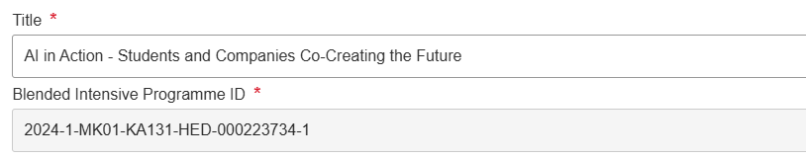

It is necessary that you insert the mobilities in the Beneficiary module so that we can have them registered in our University's profile in order to be valid.

Regarding the accommodation, our offer is:

BEST WESTERN HOTEL TURIST
- 60 EUR – Single room / 75 EUR – Twin room (breakfast included)
- Reservation e-mail: bestwestern@hotelturist.com.mk
When booking, you should insert BIP SUMMER SCHOOL ECCF (we shall inform the hotel so that they know).
In the end, thank you for sharing the CALL for our BIP Summer School among your students, duet to which we have such a good response.

Looking forward to receiving all the documents at your earliest convenience and
Being at your disposal for any further information needed,

Regards,
Marijana

